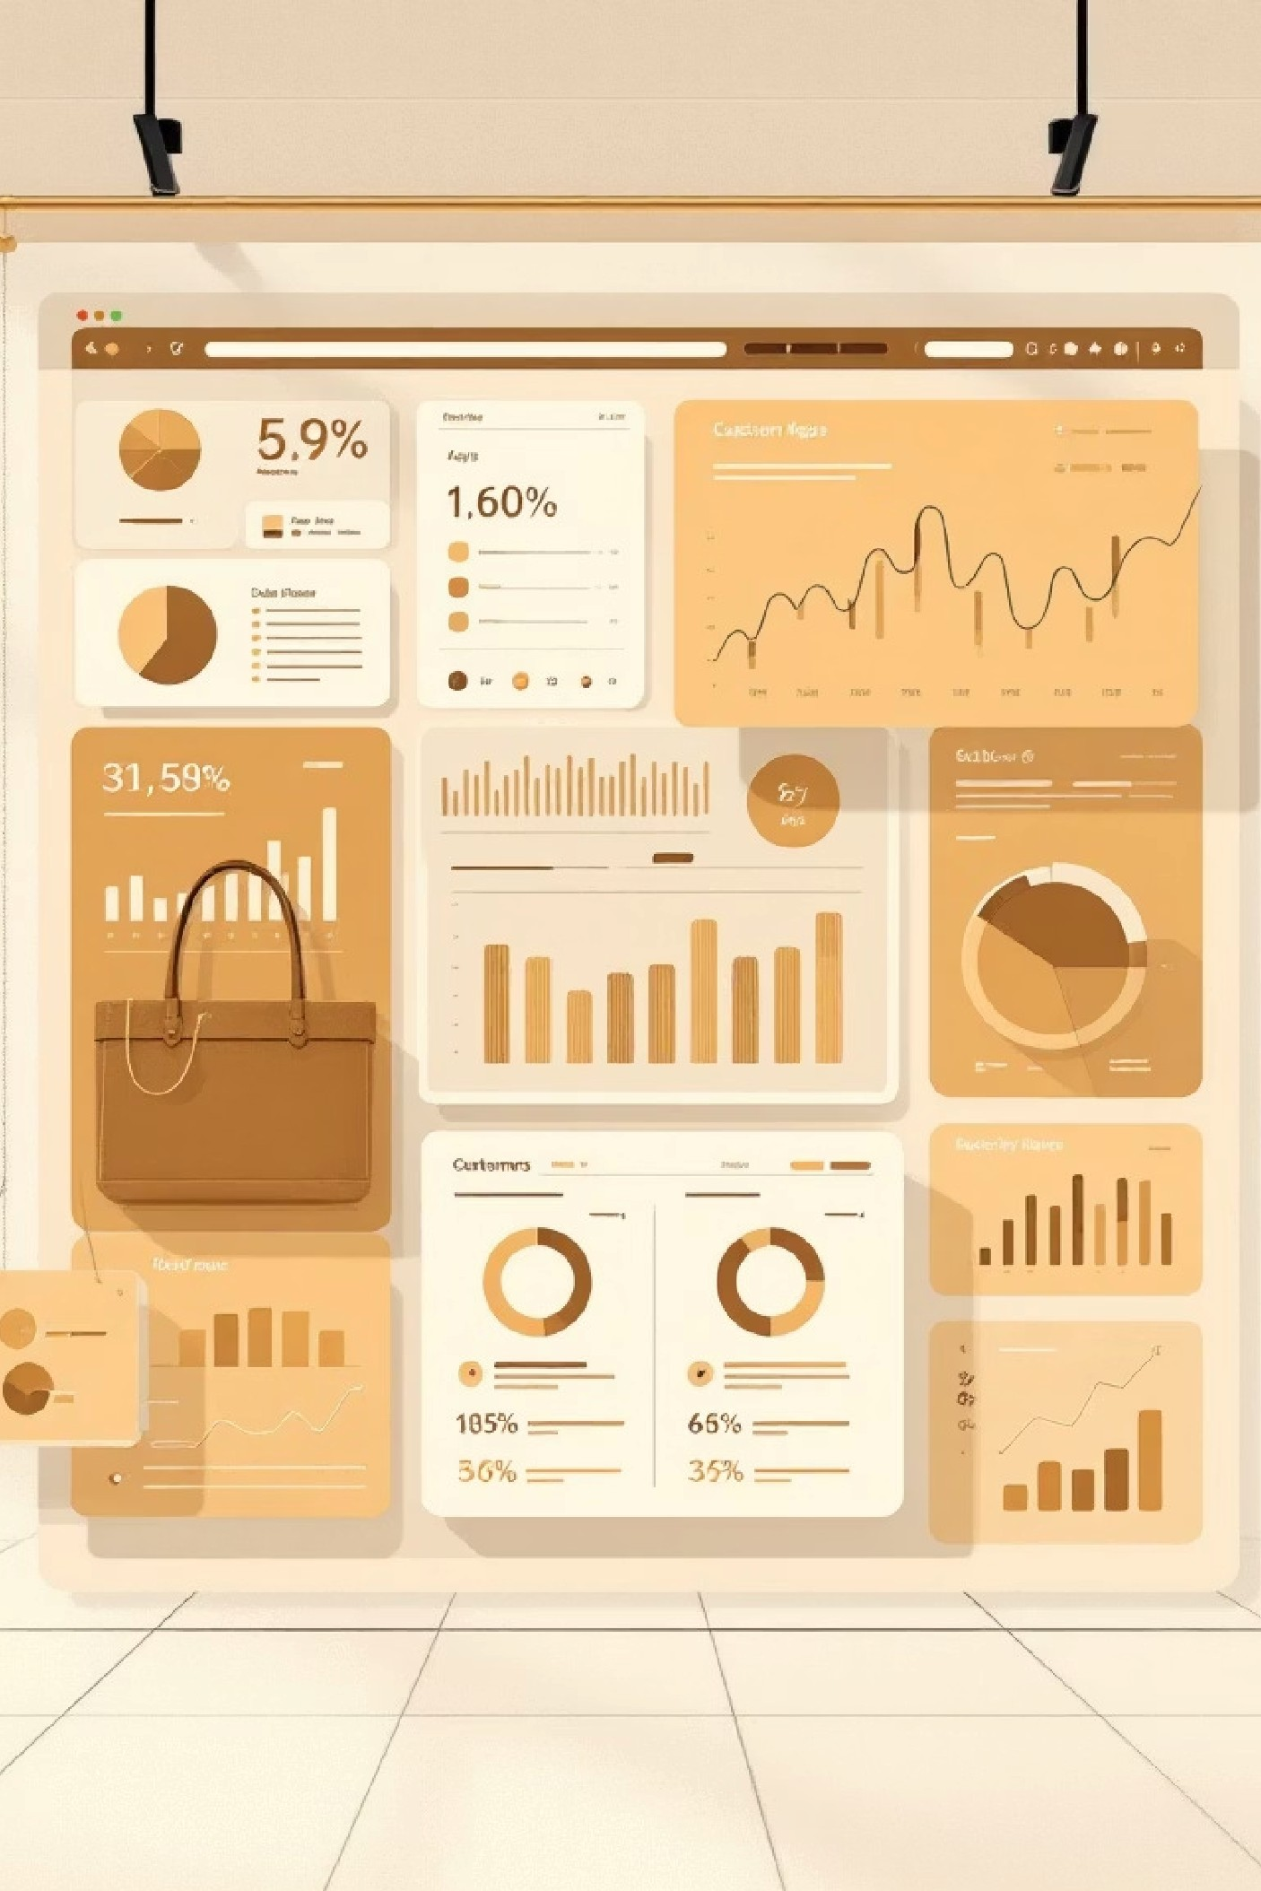

Unlocking Customer

Insights

This project analyzes customer shopping behavior using transactional data

to uncover insights into spending patterns, customer segments, product

preferences, and subscription behavior.

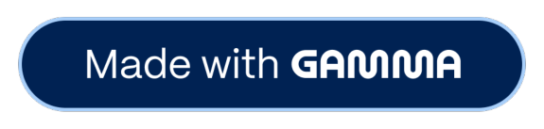

Project Overview

Goal

Uncover insights from 3,900

purchases to guide strategic

business decisions.

Data Source

Transactional data from 3,900

purchases across various

categories.

Key Areas

Spending patterns, customer

segments, product

preferences, and subscription

behavior.



Dataset Summary

Our dataset comprises 3,900 rows and 18 columns, capturing

a wealth of information about customer demographics,

purchase details, and shopping behavior.

**Customer Demographics:**

Age, Gender, Location,

Subscription Status.

**Purchase Details:**

Item Purchased, Category, Purchase

Amount, Season, Size, Color.

**Shopping Behavior:**

Discount Applied, Promo Code Used,

Previous Purchases, Frequency of Purchases, Review

Rating, Shipping Type.

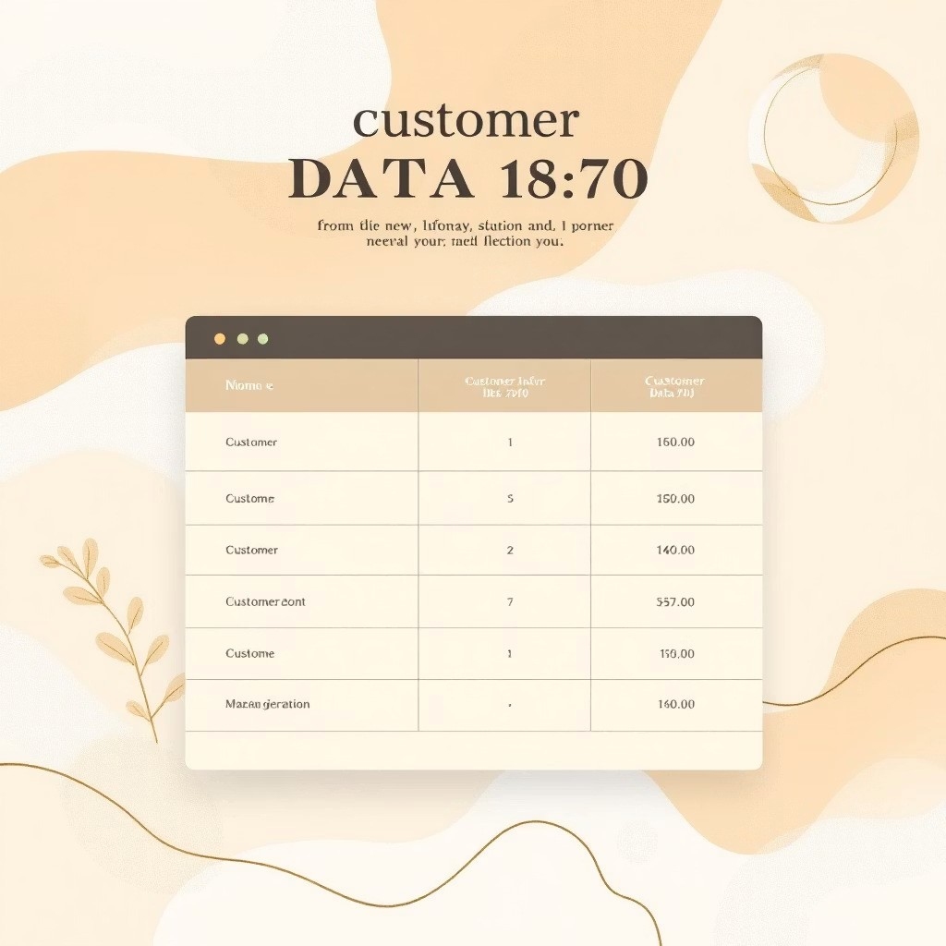

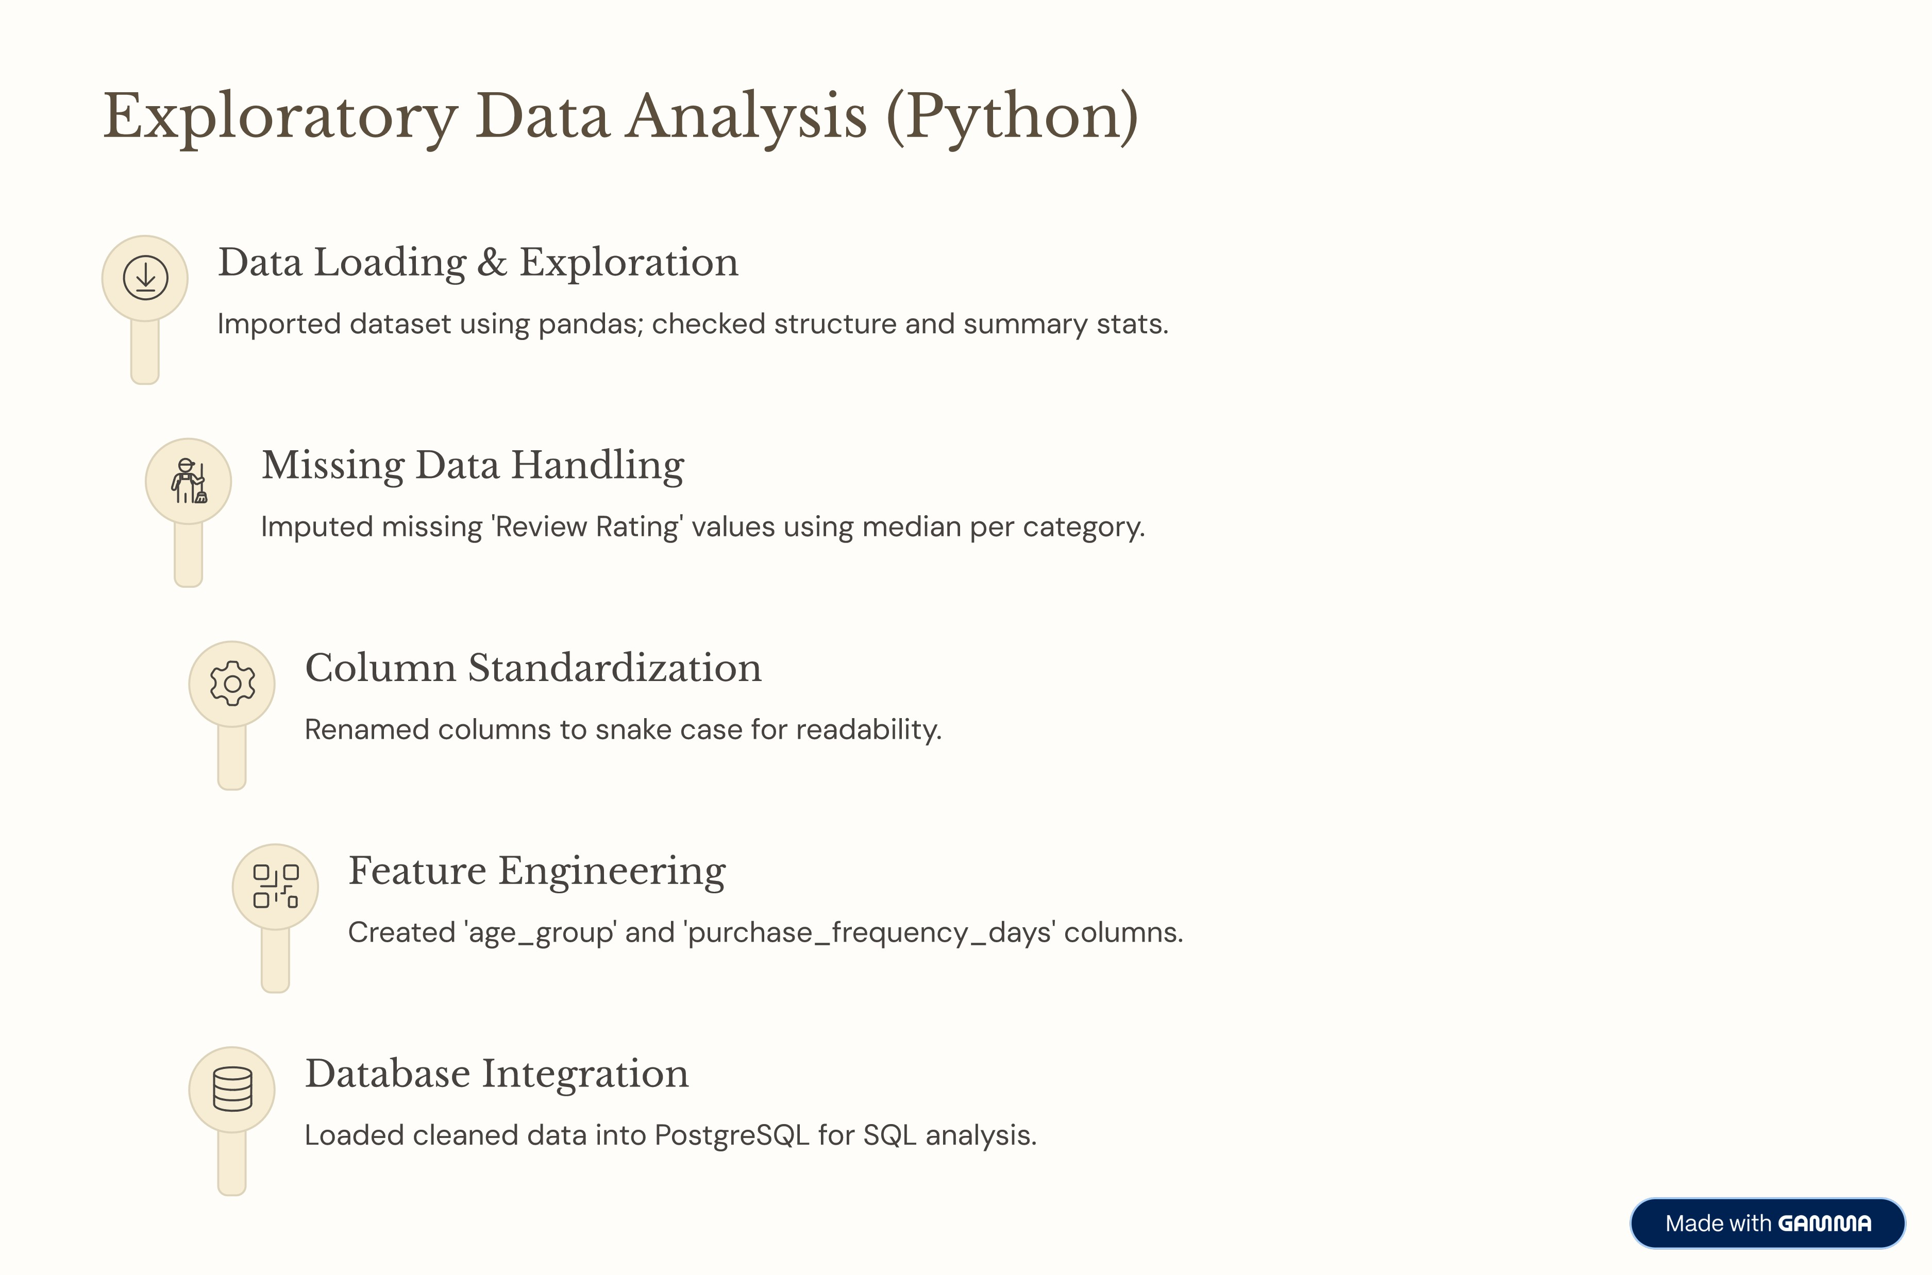



Key Business Questions (SQL Analysis)

1

Revenue by Gender

Compared total revenue generated

by male vs. female customers.

2

High-Spending Discount

Users

Identified customers using

discounts but spending above

average.

3

Top 5 Products by Rating

Found products with the highest

average review ratings.

4

Shipping Type Comparison

Compared average purchase amounts for Standard vs.

Express shipping.

5

Subscribers vs. Non-Subscribers

Compared average spend and total revenue by

subscription status.



SQL Insights: Product & Customer Focus

Discount-Dependent Products

Identified 5 products with the highest percentage of

discounted purchases.

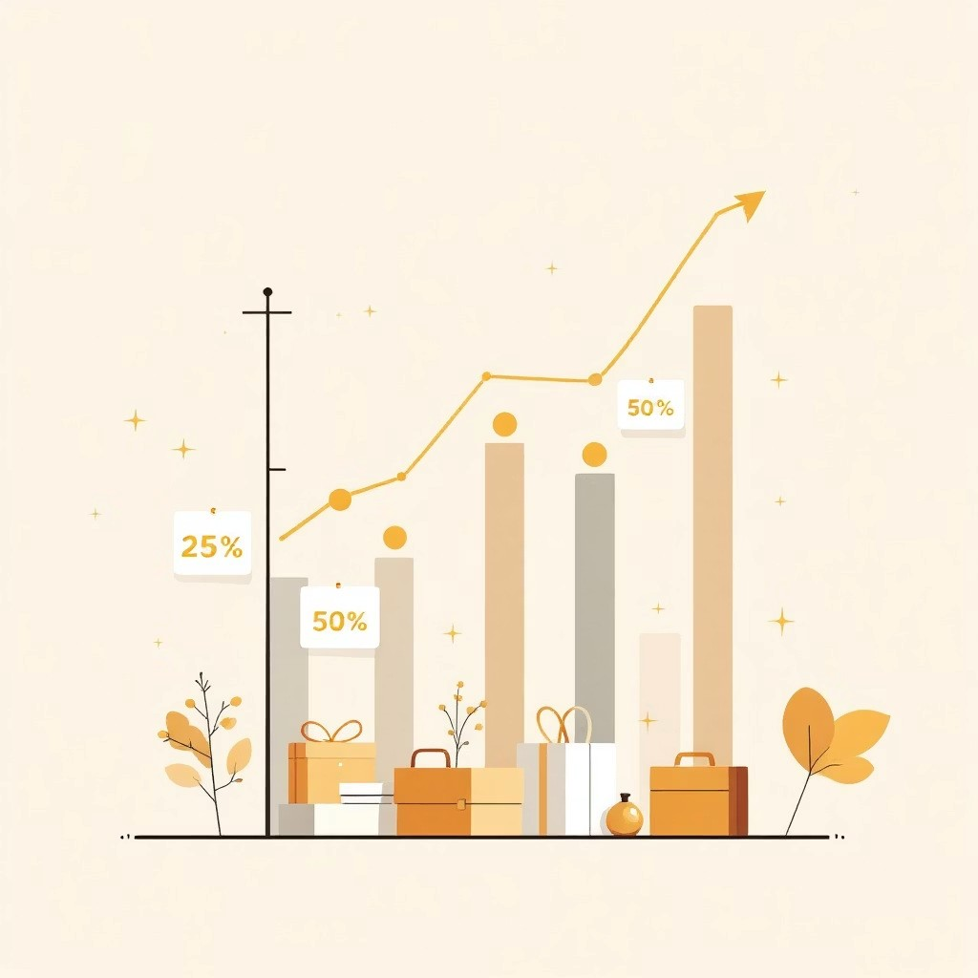

Customer Segmentation

Classified customers into New, Returning, and Loyal segments

based on purchase history.

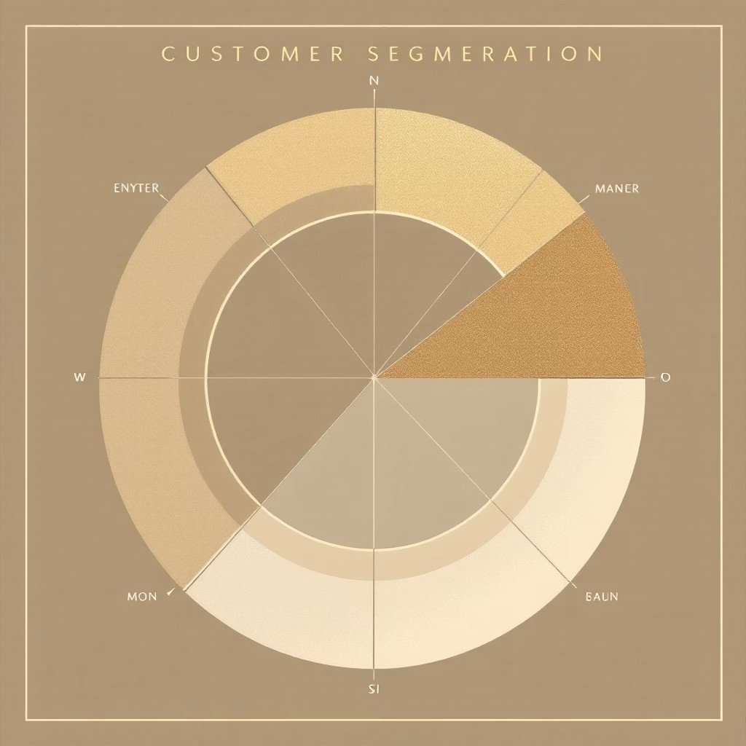

SQL Insights: Loyalty & Demographics

Repeat Buyers & Subscriptions

Checked if customers with >5 purchases are more likely to

subscribe.

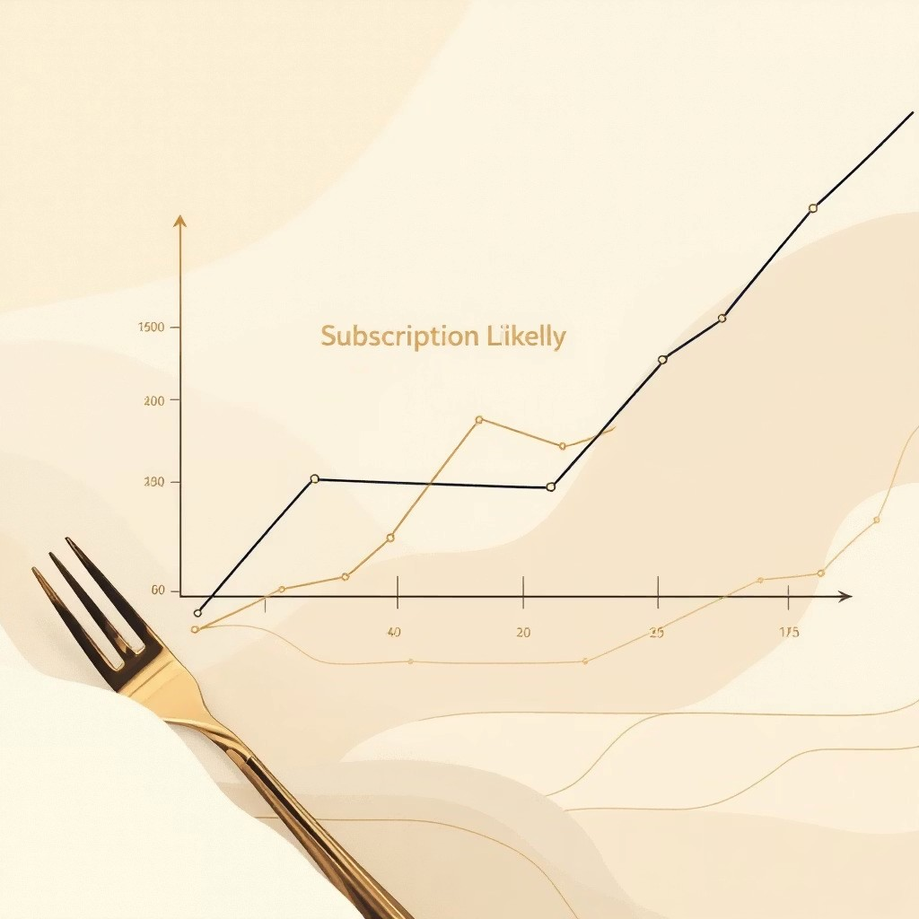

Revenue by Age Group

Calculated total revenue contribution of each age group.

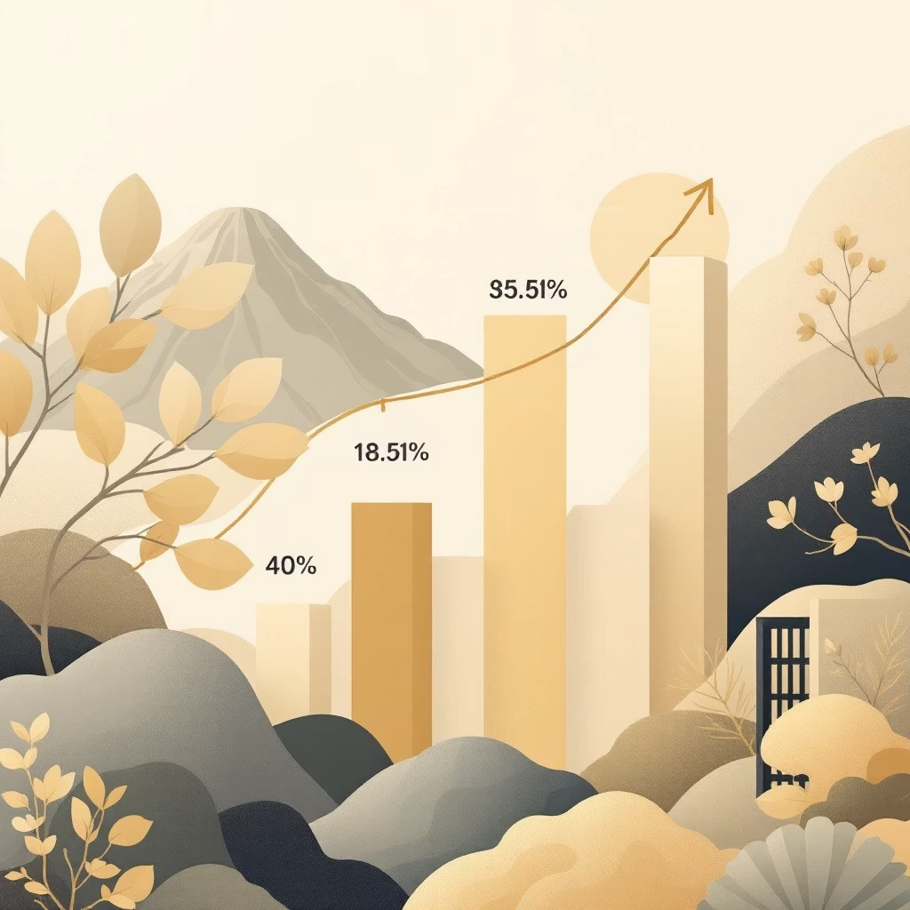

Top Products & Categories

Our analysis also revealed the most purchased products within each

category, providing valuable insights for inventory management and

marketing strategies.

Apparel

T-shirts, Jeans, Dresses

Electronics

Headphones, Smartwatches,

Laptops

Home Goods

Candles, Cookware, Decor

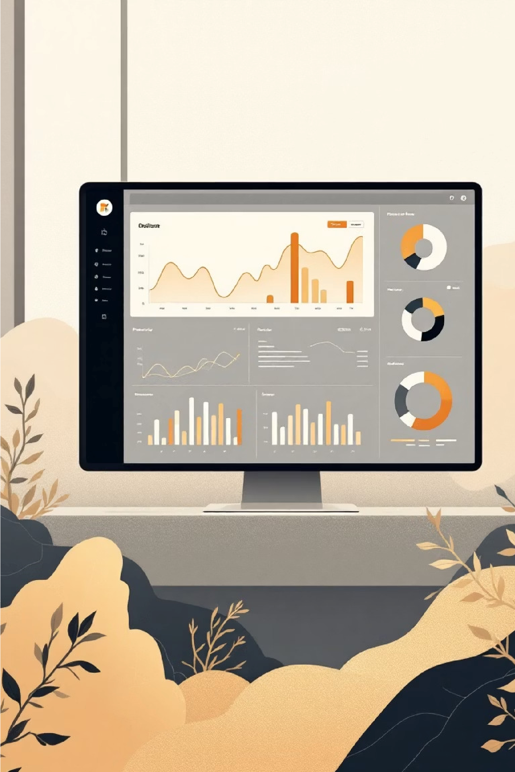

Interactive Dashboard in Power

BI

All insights were consolidated into an interactive Power BI dashboard,

allowing for dynamic exploration and visual presentation of key findings.

[**View Dashboard**](https://github.com/kalyani-analytics/Customer-Shopping-Behaviour-Analysis/blob/main/customer%20shopping%20beahavior.pbix)

**Learn More**



Business Recommendations

Boost Subscriptions

Promote exclusive benefits for subscribers to increase loyalty.

Customer Loyalty Programs

Reward repeat buyers to elevate them to the "Loyal" segment.

Review Discount Policy

Balance sales boosts with margin control for optimal

profitability.

Targeted Marketing

Focus efforts on high-revenue age groups and express-

shipping users for maximum impact.